**Put the words in the good order to write correct sentences.**

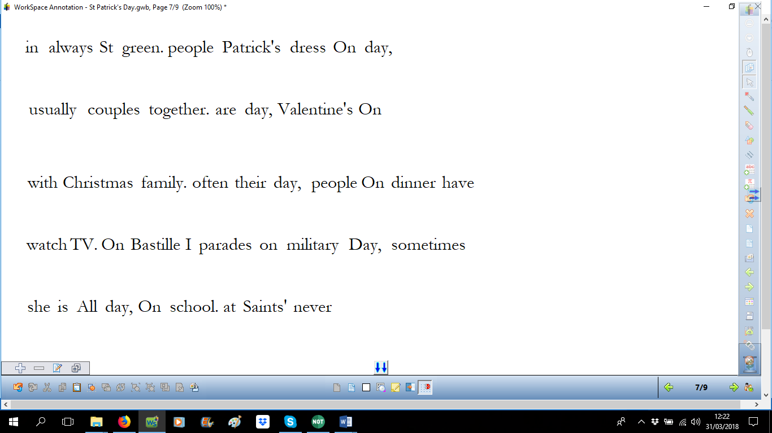

**Put the words in the good order to write correct sentences.**



**Put the words in the good order to write correct sentences.**



**Put the words in the good order to write correct sentences.**



**Put the words in the good order to write correct sentences.**

