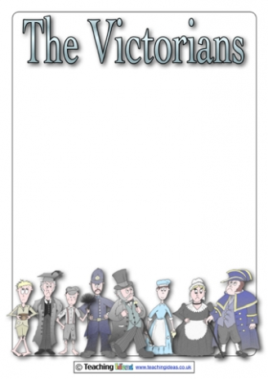

Victorian times

**I/ Queen Victoria**

Complete the biography by putting the verbs in the correct tense.

|  |  |
| --- | --- |
| C:\Users\sduffour\AppData\Local\Microsoft\Windows\INetCache\Content.MSO\96482DBF.tmp | Queen Victoria …………………………. (be) born in 1819.  She …………………………. (come) to the throne when she…………………………. (be) only 18 years old.  At the age of 21, she …………………………. (get) married with Albert of Saxe-Coburg, a German Prince. Her husband …………………………. (die) in 1861 at the young age of 42. She …………………………. (mourn) his death for almost 10 years. For the rest of her reign she …………………………. (wear) black.  She …………………………. (die) in 1901 at the age of 81.  Queen Victoria …………………………. (have) the longest reign in British history. |

**II/ Famous people in Victorian times**

1. Match.

× created the characters of Doctor Jekyll and Mister Hyde.

× wrote the famous adventures of Sherlock Holmes.

× murdered at least five women in London.

× investigated Jack The Ripper’s crimes.

× invented the telephone.

× made the first electric light bulb.

× created Alice in Wonderland.

Alexander Graham Bell ×

Frederick Abberline ×

Jack the Ripper ×

Lewis Carrol ×

Robert Louis Stevenson ×

Sir Arthur Conan Doyle ×

Thomas Edison ×

1. Rewrite as in the example.

Lewis Carrol created Alice in Wonderland

* *Alice in Wonderland was created by Lewis Carrol*

**…………………………………………………………………………………………………………………………………………………………………………………………………………………………………………………………………………………………………………………………………………………………………………………………………………………………………………………………………………………………………………………………………………………………………………………………………………………………………………………**

**…………………………………………………………………………………………………………………………….**

**III/ More activities on the net**

<https://learningapps.org/view7098178> <https://learningapps.org/view16662218>

<https://learningapps.org/view7097036>