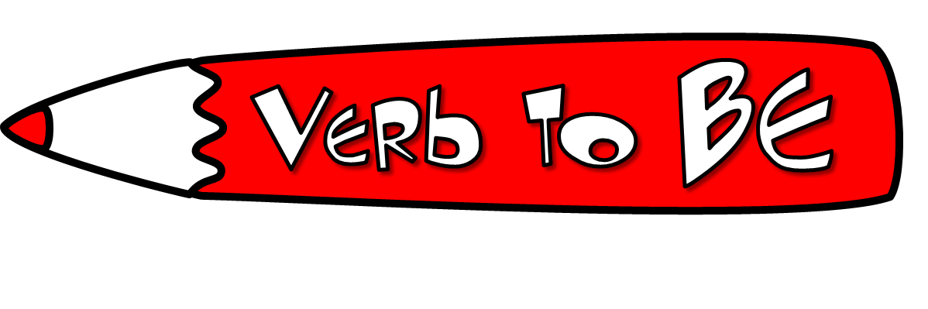

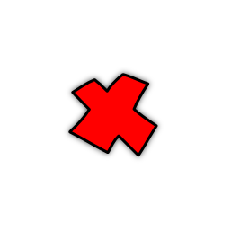

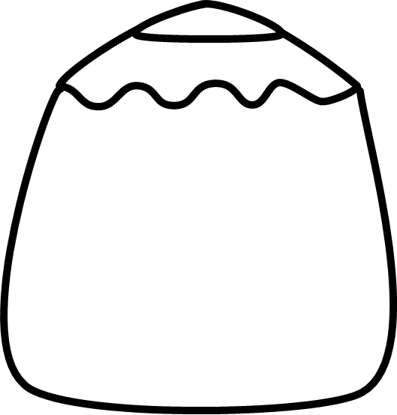
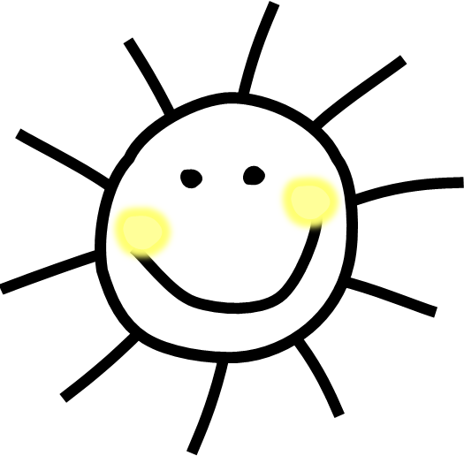


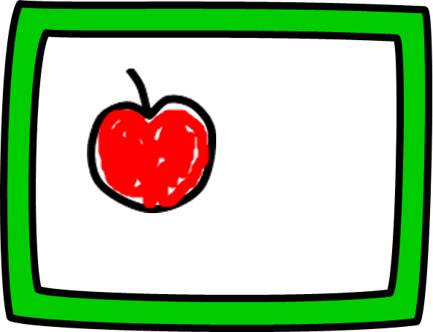
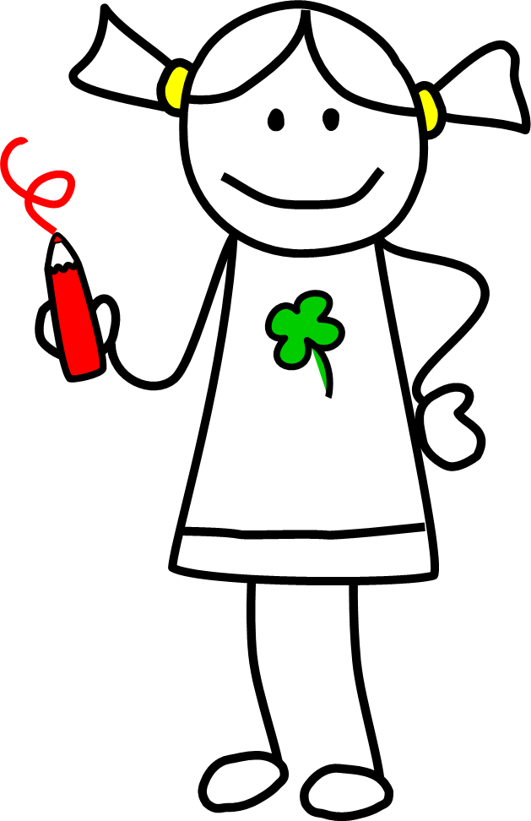


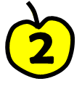
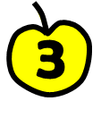
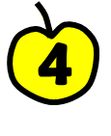
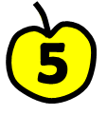
Complète avec la forme correcte de be
Mary ______ my best friend.
There ______ three fountains in the park.
My mum and I ______ often in the garden in summer. We love it.
I ______ the only child. I have two sisters.
The Wilsons ______ our neighbours.
This dress ______ too big for you. Try on a smaller size.
Mrs. Richards ______ my music teacher, Mr. Scott ______.
These boys ______ sometimes naughty. They play tricks on people.
We ______ at the cinema right now, but we don’t like the film very much.
I ______ never bored.
Réponds aux questions.
Where are you at the moment? _____________________________
How old is your mum? _____________
Is your bedroom big or small? ______________________________
Are your parents at home now? _____________________________
Where is your favourite toy right now? ______________________________
How many rooms are there in your house? ______________________________
Are you hungry? __________________
I am
You are
He
She is
It
We
You are
They
I am not
You are not
He
She is not
It
We
You are not
They
Am I ?
Are you ?
he ?
Is she ?
it ?
we ?
Are you ?
they ?
Choisis le bonne réponse.
Sally ____ in her room now, she _____ in
the bathroom.
a) is / isn’tb) isn’t / isc) isn’t / are
Luke and Helen ____ cousins.
a) isn’t b) amc) aren’t
Pam and I ____ best friends.
a) areb) am notc) am
Jack ____ Mr. Lawson’s grandson.
a) isb) arec) am
We ____ friendly and helpful. Everybody likes us.
a) isb) aren’tc) are

Corrige les erreurs.
There is five lamps in the classroom. ______________________________
My dad and I am both tall.
______________________________
The postcard are from Greece.
______________________________
Where is the Morgans?
______________________________
Réécris en utilisant les formes contractées (formes courtes de BE).
The dogs are not very tired.
______________________________
I am optimistic and outgoing.
______________________________
He is never moody.
______________________________
My mum is not a dentist.
______________________________
We are often at work till late.
______________________________

