The legend of Finn MacCool and the Giant’s Causeway
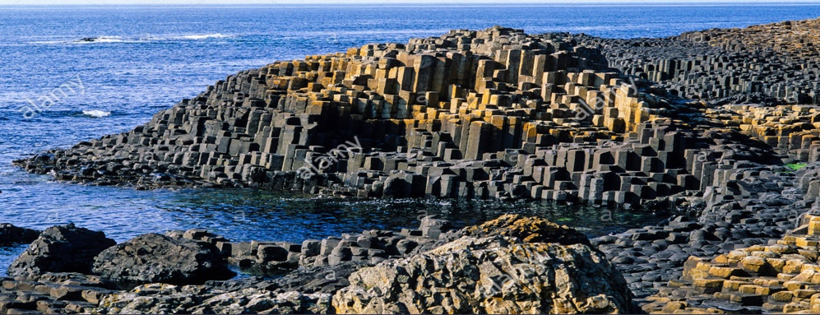
According to the legend, Finn MacCool was an Irish giant.
One day, Finn was going about his daily duties in Northern Ireland when one of his enemies, a giant named Benandonner, who lived in Scotland on the other side of the sea, started shouting out insults at him. He was rude to Finn and said he was weak and no good at fighting.
Finn was so furious that he decided to build a bridge to cross the sea in order to meet and challenge the Scottish giant. So he threw enormous columns of rock inside the water and managed to create a passage to Scotland: the Giant’s Causeway.
When Finn caught sight of Benandonner as he started to cross the causeway he realized how gigantic his Scottish rival was. He panicked and ran back to Ireland. At home, he told his wife Oonagh the whole story.
Benandonner heard Finn running away so he crossed the causeway and went to Ireland to fight his enemy. Before the Scottish giant knocked at the door, Oonagh had a clever idea. She disguised Finn as a baby and told him to lie in a cot.
When the Scottish giant arrived at Finn’s house he shouted, “Where is that coward MacCool?” Then he noticed the cot and the sleeping ‘baby’ inside it and he suddenly felt very afraid. He thought, “My goodness, if this is the size of the baby, what size must the father be?”
Without waiting around to find out, he turned on his heels and ran like he had never run before. He ran back across to Scotland, destroying the causeway as he went, so that Finn could not come after him.
And that is why only two fragments of the causeway now remain, one end on the coast of Northern Ireland and the other on the Scottish island of Staffa.
