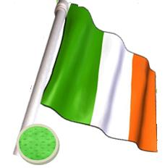banner02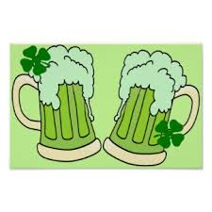banner02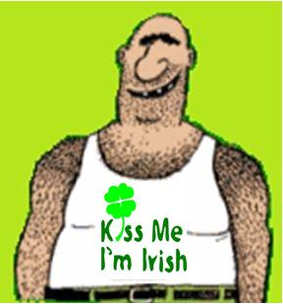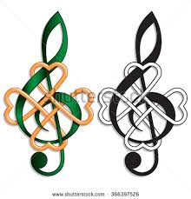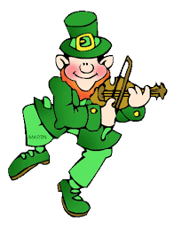MC900324470[1]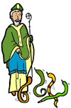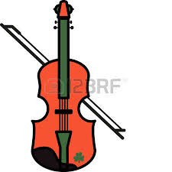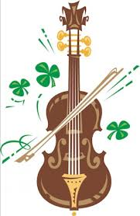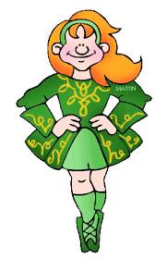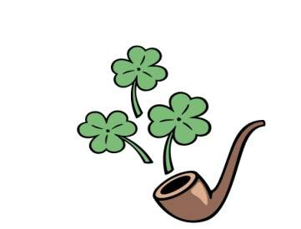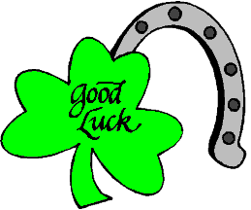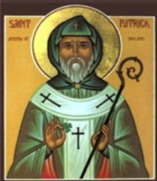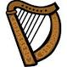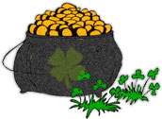

|  |  |  |  |  |  |  |  |  |  |
| --- | --- | --- | --- | --- | --- | --- | --- | --- | --- |
| **B** | **U** | **L** | **Y** | **I** | **G** | **I** | **J** | **Q** | **O** |
| **H** | **V** | **P** | **U** | **Z** | **U** | **R** | **I** | **E** | **R** |
| **G** | **H** | **E** | **B** | **C** | **M** | **I** | **E** | **A** | **E** |
| **A** | **R** | **E** | **M** | **I** | **K** | **S** | **U** | **E** | **D** |
| **L** | **E** | **P** | **R** | **E** | **C** | **H** | **A** | **U** | **N** |
| **E** | **V** | **X** | **A** | **M** | **I** | **A** | **X** | **Y** | **A** |
| **L** | **O** | **D** | **I** | **T** | **R** | **M** | **U** | **F** | **L** |
| **L** | **L** | **G** | **N** | **J** | **T** | **R** | **T** | **V** | **E** |
| **I** | **C** | **I** | **B** | **G** | **A** | **O** | **T** | **M** | **R** |
| **H** | **A** | **A** | **O** | **S** | **P** | **C** | **K** | **E** | **I** |
| **S** | **Y** | **L** | **W** | **S** | **E** | **K** | **A** | **N** | **S** |
| **O** | **D** | **V** | **L** | **I** | **Y** | **P** | **Q** | **E** | **M** |

________________________________________________ ________________________________________________ ________________________________________________________________________________________________________________________________________________

***UNSCRAMBLE* TS PCKATRIS DYA ___________________ ERINDAL _____________ GAFL _________ FROU LFEA CVLOER __________________ BONAIRW _______________ NPERCHAELU __________________ BUDINL ____________ HIISR ___________ PTO FO LGDO ___________________ CKLU ___________ MRAHC ___________ ERENG __________ RAPH ____________ KRHSMAOC __________________ SUCMI ____________ GJI ____________ DLFDIE ___________ IEPP __________ ERENG EBRE ___________________ KNASSE ______________ NHICP __________ STLEFAB _____________**

**four-leaf clover**

**leprechaun hat**

**map of Ireland**

**fiddle**

**gold coin**

**jig**

**music**

**pinch**

**snakes**

**leprechaun**

**pipe**

**rainbow**

**shamrock**

**luck**

**St Patrick**

**Irish flag**

**harp**

**green beer**

**pot of gold**

**March 17th**