Saint Patrick’s day quiz
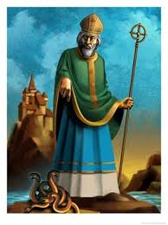
1) What’s his name?
⃝ Saint Georges
⃝ Saint Patrick
⃝ Saint Andrew

2) When is his Day?
⃝ 15th March
⃝ 16th March
⃝ 17th March

3) Which colour do you wear on this day?
⃝ Green
⃝ Red
⃝ Blue
4) Where is this celebration from?
⃝ England
⃝ Scotalnd

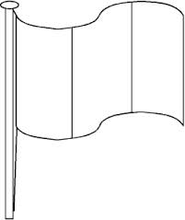
5) What colour is the Irish flag?
⃝ Green, white, orange
⃝ Blue, white, red
⃝ Green, white, red
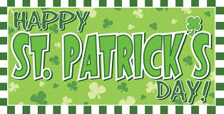
6) What is the Capital city of the Republic of Ireland?
⃝ London
⃝ Belfast
⃝ Dublin

7) What is the capital city of Northern
Ireland ?
⃝ Dublin
⃝ London
⃝ Belfast
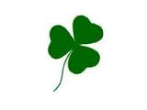
8) What is this?
⃝ a flower
⃝ a shamrock
⃝ a tree
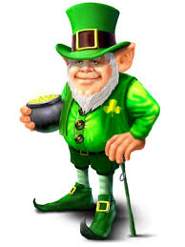
9) What’s his name?
⃝ a dwarf
⃝ a wizard
⃝ a leprechaun

10) What is Ireland’s nickname?
⃝ The Green Island
⃝ the Jade land
⃝ The Emerald Isle

TOTAL: ……………….. POINTS
Answers: 1)Saint Patrick 2)17th March 3)Green 4)Ireland 5)Green,white,orange 6)Dublin 7)Belfast 8)a shamrock
9) a leprechaun 10)The emerald isle

