Ireland facts and figures
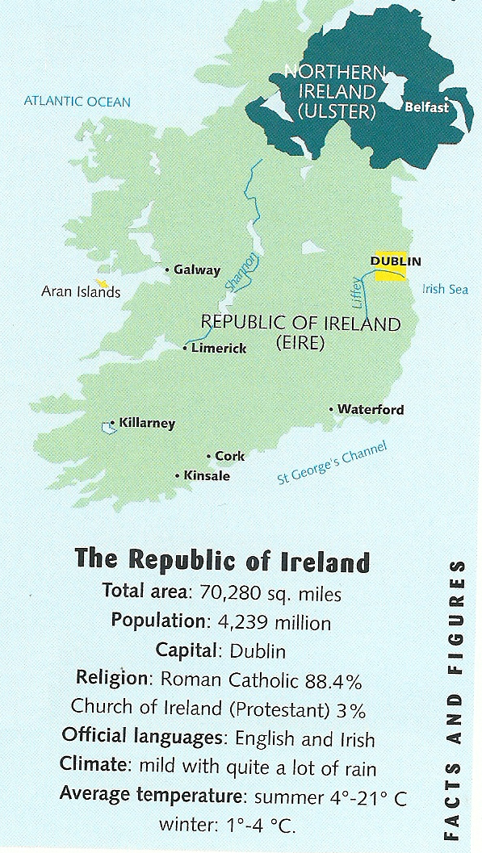
Sers-toi des informations en-dessous de la carte pour compléter le texte ci-dessous. Écris les nombres en toutes lettres.

The total area of the Republic of Ireland is……………………………
…………………………………………………………………………
…………………………………………………………. square miles.
There are ……………………………………………………………….
…………………………………………………………………………………………………..................................................…… people in Eire.
The capital city is Dublin.
Roman Catholics represent ……………………………………………
…………………………………. per cent of the population while …………… per cent of the population is Protestant.
The official languages are English and Irish.
The climate is mild with quite a lot of rain.
In Summer, the average temperature varies between ………………..
to ………………………………………………. degrees Celcius. In winter, it fluctuates between ……………… to …………….. degrees Celcius.
Irish people living abroad
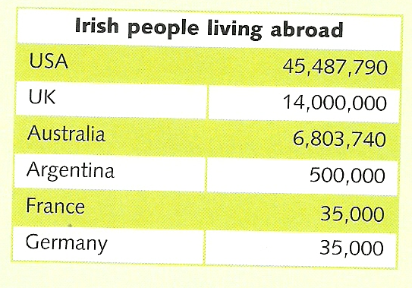
Voici le nombre de personnes d’origine irlandaise qui vivent à l’étranger. Écris ces nombres en toutes lettres.

In the USA : ……………………………………………………
………………………………………………………………………………………………………………………………………………………………………………………………………
In the UK : ………………….…………………………………
………………………………………………………………………………………………………………………………………………………………………………………………………
In Australia: ……………….…………………………………
……………………………………………………………………………………………………………………………………………………………………………………………………… In Argentina: ……………….…………………………………
………………………………………………………………… In France: ……………….…………………………………
………………………………………………………………… In Germany: ……………….…………………………………
…………………………………………………………………

