3A Groupe 1
Travail pour la période du 18 au 22 octobre (quand le groupe 2 est en classe)
Hello!
Voici ton travail:
- À l’aide du document ci-dessous, fais la correction du travail donné pendant le confinement (2è dossier)
- Apprends les leçons et le vocabulaire étudiés en classe la semaine dernière (si tu étais absent, copie les leçons 2 et 3 et apprends-les)
- Lis le Toolbox 1 p 46 et fais l’exercice 1 p 47
- Fais les activités de la fiche « Making hypotheses » et apprends le Wordbox et la rubrique « récapitulons » du Toolbox
- Devoir à rendre évalué : Révise le chapitre avant de faire le devoir. Lis bien la consigne et rédige ton devoir en anglais. Il devra être propre !
Have fun !
H

Lockdown activities
Correction
(2ème dossier)
I/ Queen Victoria
Queen Victoria was born in 1819. She came to the throne when she was only 18 years old. At the age of 21, she got married with Albert of Saxe-Coburg, a German Prince. Her husband died in 1861 at the young age of 42. She mourned his death for almost 10 years. For the rest of her reign she wore black. She died in 1901 at the age of 81. Queen Victoria had the longest reign in British history.
II/ Famous people in Victorian times
a)
Alexander Graham Bell invented the telephone.
Frederick Abberline investigated Jack the Ripper’s crimes.
Jack the Ripper murdered at least five women in London.
Lewis Carrol created Alice in Wonderland.
Robert Louis Stevenson created the characters of Doctor Jekyll and Mister Hyde.
Sir Arthur Conan Doyle wrote the famous adventures of Sherlock Holmes.
Thomas Edison made the first electric light bulb.
b)
The telephone was invented by Alexander Graham Bell
Jack the Ripper’s crimes were investigated by Frederick Abberline
At least five women were murdered by Jack the Ripper in London.
The characters of Doctor Jekyll and Mister Hyde were created by Robert Louis Stevenson.
The famous adventures of Sherlock Holmes were written by Sir Arhur Conan Doyle.
The first electric light bulb was made by Thomas Edison.
III/Victorian times
a) Une heure commune a été adoptée dans toutes les villes après la mise en place des chemins de fer et des trains.
b) Les maillots de bain couvraient le corps des femmes tout entier car elles n’avaient pas le droit de montrer leurs jambes ni même leurs chevilles.
c) Londres était très pollué parce que la plupart des foyers faisaient brûler du charbon plutôt que du bois.
d) Il y avait des employés dont le travail était d’aller frapper à la porte des ouvriers pour les réveiller.
IV/Jack the Ripper
He was a dangerous serial killer. He attacked several women in 1888. His name “Jack the Ripper” was created by the killer himself.
His method: Throats cuts => victimes égorgées; abdominal mutilations and removal of internal organs => mutilations au niveau du ventre et les organes étaient retirés.
V/ Wordsearch
The 15 words were: corpses, From Hell, killer, mutilation, suspect, crimes, investigation, letters, police, victims, kidney, London, prostitute, Whitechapel
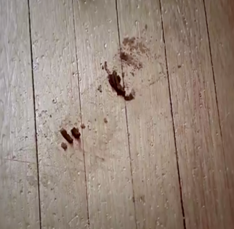
III/ Wordbox: Crimes
1/strangle 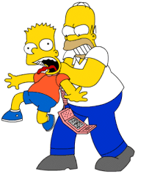with a rope or a scarf 2/Poison 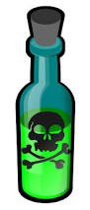
3/ run over with a car 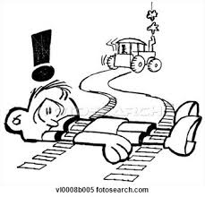 4/Stab with a knife 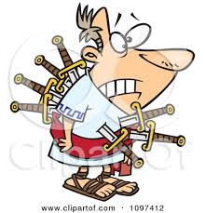5/ drown 6/shoot with a gun 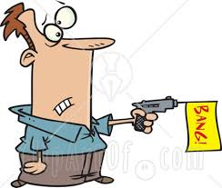
7/ knock out with a baseball bat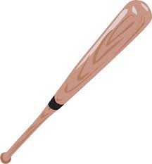 8/electrocute 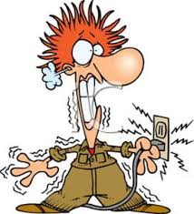
9/ kidnap 10/ push down the stairs 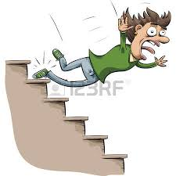

II/ Toolbox
Let’s be better detectives than Ashley! Look at the crime scene.
What are the best clues (= indices) for this crime? (Numérote par ordre d’importance).
…….. the tea …….. the gun …….. the footprint
So, what are the best options, from the least probable to the most probable? (Numérote du moins probable au plus probable).
A) The killer may have just left ………
B) Someone might have poisoned the tea ………
C) The murderer must have shot the victim with a gun ……..

To conclude, to make hypotheses, you have to use the modals ……………….., …………………. or ……………….. + HAVE + PAST PARTICIPLE.

Récapitulons : Pour faire des hypothèses au passé, on peut utiliser :
MIGHT HAVE + PARTICIPE PASSÉ pour dire qu’il y a peu de chances (+)que ce soit arrrivé comme dans l’exemple B (quelqu’un pourrait avoir empoisonné le thé mais c’est très peu probable !)
MAY HAVE + PARTICIPE PASSÉ pour dire que cela est possible à 50% de chances (++++) comme dans l’exemple A (Il est possible que le tueur vienne de partir, il y a des empreintes de pied sur le sol.)
MUST HAVE + PARTICIPE PASSÉ pour dire que cela est fort possible à 90% (+++++) de chances comme dans l’exemple C (Il y a une arme à côté de la victime donc il est fort possible qu’elle ait été tuée par balle.)
IV/ Let’s practise now
Miss Duffour has strangely disappeared after a class with the 3A. Nobody likes her in this class so every 3A student is a suspect! Make hypotheses using the elements. Follow the example:
Eva / / ++++ => Eva may have strangled Miss Duffour with a rope
Ylan / / ++++++ => ………………………………………………………………….
Melinda / / + => …………………………………………………………………………………..

À toi d’imaginer des hypothèses sur la disparition de Mme Duffour. Dans ton cahier, écris 5 autres phrases.
Let’s discover a crime scene and make hypotheses
I/ Watch the video : https://learnenglish.britishcouncil.org/en/word-street/murder-mystery-scene-1
Then, answer the questions (Pour répondre aux questions, regarde de nouveau les 3 premières minutes)
a) First part
How many people can you see? We can see 2 3 people
Where are they? They are in a living-room in a mansion in a room in a museum
Why are they here for? They are here to visit Sherlock Holmes’s museum
to play a detective game
What is Ashley wearing? She is wearing a casual outfit a detective outfit
What can you say about her attitude? She is serious She is funny
So, what does she want? She wants to solve the mystery and win the game
She only wants to have fun
b) Second part
Pete is explaining Steven the game. What are the rules?
A person is chosen to be the murderer and the other people have to guess who it is.
As the game continues, there are more and more victims.
You have to find the killer by analyzing the clues.
c) Last part
For Ashley, what is the murder weapon? The tea the gun
Is she right or is she wrong? She is right She is wrong
What can you say about Ashley as a detective? She is a good detective She is a bad detective

