Reviews 1 (Friday 20th March)

- Review lessons 1, 2 and 3 (révise les leçons 1, 2 et 3 du chapitre 1 dans ton cahier)
- Speaking: Answer the questions (réponds aux questions à voix haute) : What’s your first name? and your surname? Can you spell it please? When and where were you born? Where do you live? Do you have any sisters and brothers?
- Write these dates in full: 18.02.2019 , 14.07.1789 , 17.03.2005 , 31.10.1946 , 25.12.2000 (écris ces dates en toutes lettres; N’oublie pas d’utiliser les nombres ordinaux)
- Write a paragraph about your best friend: name / age / date of birth/ place of birth/ Address / Phone number / family (écris un paragraphe pour présenter ton meilleur ami)

Reviews 2 (Monday 23rd March)

- Review lessons 4, 5, 6 and 7 and vocabulary (révise les leçons 4,5,6 et 7 et le vocabulaire de chaque leçon dans le chapitre 1 dans ton cahier)
- Speaking : compare your classmates (compare tes camarades) : Example: John is more good-tempered than Lucie. Mary is lazier than Luke
- Writing: Write a paragraph about your best friend (name, personality, physical description and fashion style) : écris un paragraphe sur ton meilleur ami, son caractère, comment il est physiquement et comment il s’habille habituellement

Final writing assessment (Tuesday 24th March)

- Réalisation d’un fan booklet : présente et décris la star ou la personne de ton choix.

- Je présente la star ou la personne de mon choix (nom, âge, date et lieu de naissance, famille)
- Je parle de sa personnalité (2 adjectifs et degrés)
- Je décris son apparence physique ( taille et corpulence, cheveux et yeux)
- Je parle de ses habitudes ou loisirs (2 adverbes de fréquence)
- Je parle de ses vêtements (2 éléments au moins)

Si je ne sais pas, j’invente !!! Mais je respecte chaque étape de la consigne !!

CHAPTER 2: THE LAND DOWN UNDER

Lesson 1: The Land of the Oz (Thursday 26th March)

- Look for information on the net or in your book and fill in the form (va sur internet ou cherche dans ton livre p52 ou dans le livret Quick Facts de ton manuel p2-3 et complète le formulaire)
- Complete the text with the information you have gathered (puis complète le texte avec les informations recueillies)
WEBQUEST
- 1) Which country is it? …………………………………………………………………………..
- 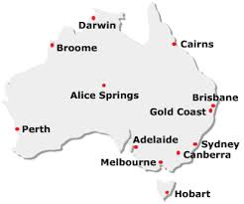
- 2) Fill in the map with the names of the cities missing.
- 3) Complete:
- Nickname of the country:
- Geographical situation: Total area:
- Name of the inhabitants:
- Number of the inhabitants:
- Language spoken: National Day:
- Capital city: Biggest city:
- Currency:
- Draw the flag in the box:

- Name these famous places: Sydney Opera House, The Pinnacles, Uluru, Perth Arena, The Great Barrier Reef
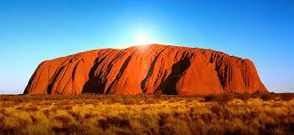
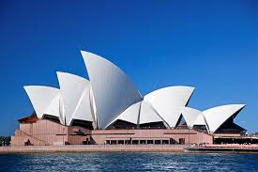
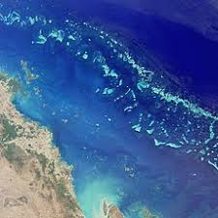
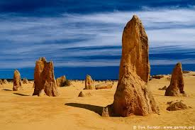
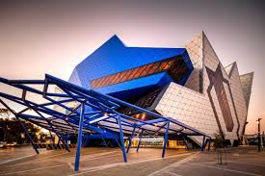

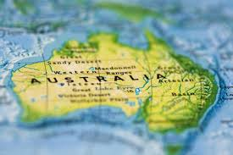 | …………………………………………… is a huge and beautiful country. It is nicknamed ……………………………………………………………….…… because it is situated in ……………………………………………………… . The total area is ………………………………………………………….. km2 (square kilometers). There are …………………………………………….. inhabitants in Australia and they are called the ………………… . The capital city is ………………………………….. but the biggest city is ………………………………….. . The national currency is ………….... ……………………………. and the national language is ……………… . The colours of the flag are ……………………., ………………………… and …………………………….. . The single seven-pointed star on the left represents the seven states and territories of Australia and the five stars on the right represent the Southern Cross. Australian people celebrate their national day on …………………………………………………………………. .

Lesson 1: The Land of the Oz ( Friday 27th March)

- Learn the information you have gathered on Australia ( apprends par coeur les informations que tu as recueillies sur l’Australie)
- Copy and answer the questions: Copie et réponds aux questions
Where is Australia?
How are the inhabitants called? (comment appelle-t-on les habitants?)
What is the national currency? (la monnaie)
What colour is the flag?
What is the capital city?
What is the biggest city?

Learning session (Monday 30th March)

- Speaking: Answer the questions (réponds à haute voix aux questions):
Where is Australia?
How are the inhabitants called? (comment appelle-t-on les habitants?)
What is the national currency? (la monnaie)
What colour is the flag?
What is the capital city?
What is the biggest city?

- Learn the irregular verbs p 144 from BE to COME (apprends par coeur les verbes irréguliers p 144 de BE jusqu’à COME)
Learning session (Tuesday 31st March)

- Review the verbs p 144 (be=> come)
- Do the checkpoint
- Check point
- Do you know your verbs?

be | Was/were
 | became | become
 |  | begun | commencer
build |  |  | construire
choose | chose

- Auto correction:
- Check your answers and count your points: ………………/10
Between 8-10 points |  | Well done! You know your lesson!
Between 5-7 points | 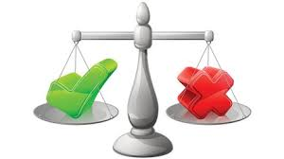 | Not too bad! But you have to revise!
Between 1-4 points |  | Learn your lesson again!!!

Learning session (Friday 3rd April)

- Review the verbs p 144 (be=> come)
- Learn the verbs p 144 (cut => find) (apprends par coeur les verbes p 144 de CUT jusqu’à FIND)

