**Listening / Compréhension orale**

Listen to Rachel and Georgia and circle the school things they have in their school bag.

Ecoute Rachel et Georgia et entoure les fournitures qu’elles ont dans leur cartable.

|  |  |
| --- | --- |
| **Rachel** | **Georgia** |
| Calculator , calculator transparent background PNG clipart | HiClipartYellow Pencils Clip Art at Clker.com - vector clip art online, royalty free  & public domainGlue Stick Hd Transparent, Yellow Glue Stick Clip Art, Glue Stick Clipart,  Yellow, Stationery PNG Image For Free DownloadPng scissors clipart, transparent background. | Free PNG - rawpixelRubber PNG HD Image | PNG AllKeys Stock Illustration - Download Image Now - Cartoon, Key, Art - iStockImage clipart vectoriel Diary | Vecteurs publiquesBIC 4-Colour Multipen MiniFree clip art "Ruler" by molumenLunch Box Stock Illustrations – 43,127 Lunch Box Stock Illustrations,  Vectors & Clipart - DreamstimeGreen Highlighter - OpenclipartFREE Composition Notebooks Clipart | Pearly Arts | Free clip art "Ruler" by molumenKeys Stock Illustration - Download Image Now - Cartoon, Key, Art - iStockRubber PNG HD Image | PNG AllCalculator , calculator transparent background PNG clipart | HiClipartLunch Box Stock Illustrations – 43,127 Lunch Box Stock Illustrations,  Vectors & Clipart - DreamstimeGreen Highlighter - OpenclipartFREE Composition Notebooks Clipart | Pearly ArtsBIC 4-Colour Multipen MiniGlue Stick Hd Transparent, Yellow Glue Stick Clip Art, Glue Stick Clipart,  Yellow, Stationery PNG Image For Free DownloadImage clipart vectoriel Diary | Vecteurs publiques |

**vocabulary**

Find in the grid the 12 school subjects / Retrouve dans la grille les 12 matières scolaires.

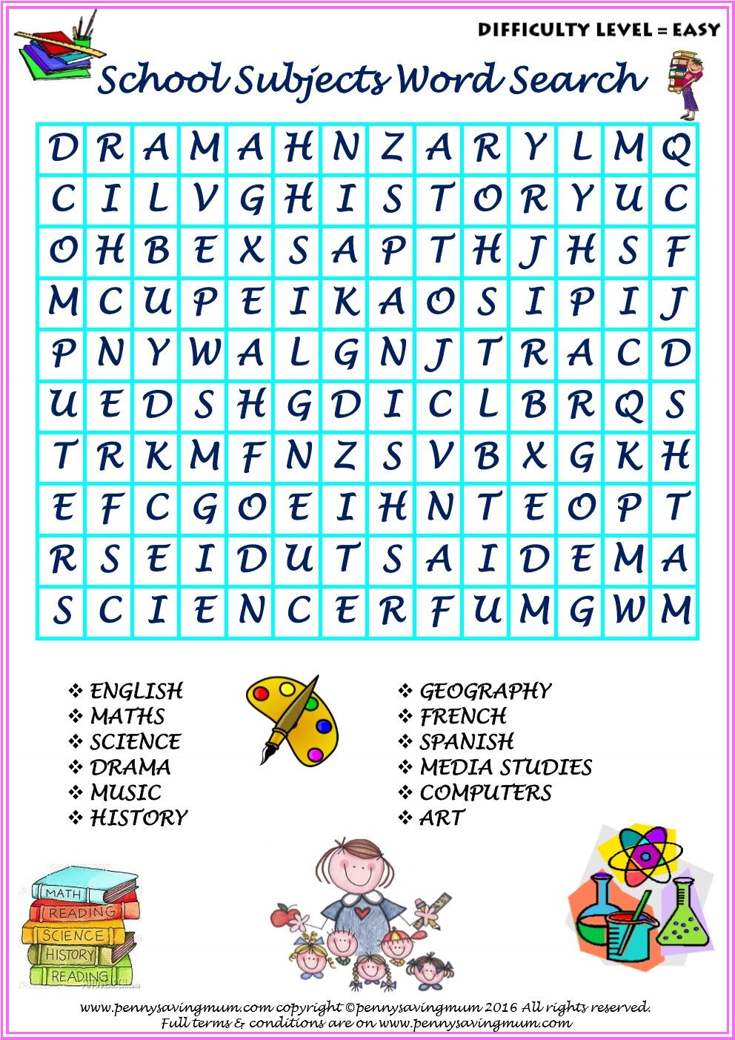

**Reading and understanding/ Lire et comprendre**

Read the text about the seasons and the weather and number the pictures.

Lis le texte au sujet des saisons et de la météo et numérote les images.

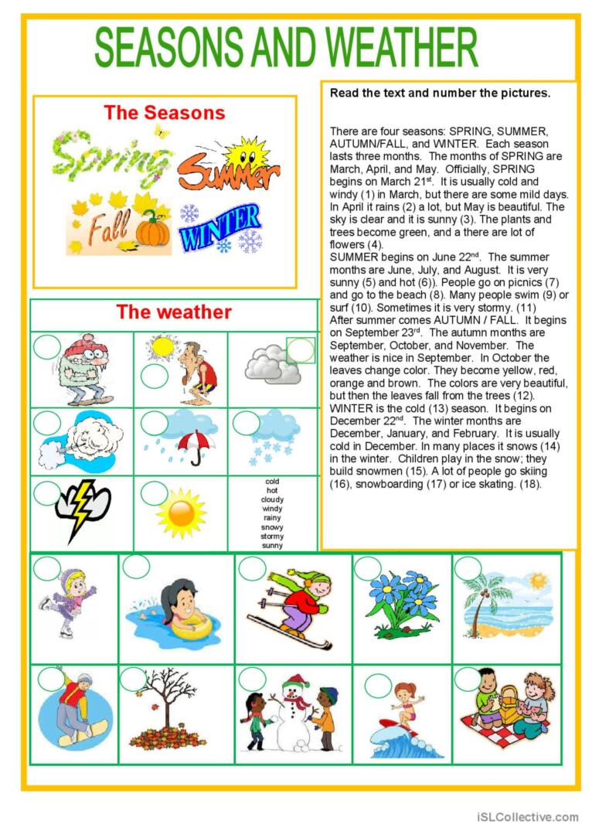

Trouve the chemin et écris le mot.

