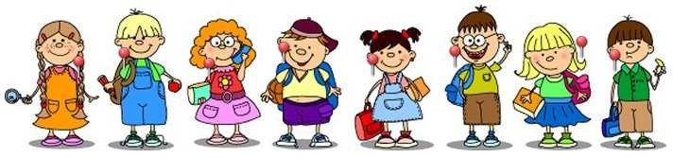

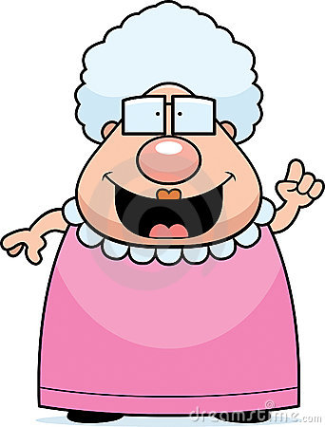



**Look at the picture and use the words below to complete the gaps.**

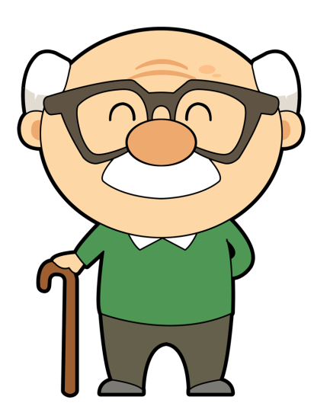

These are my grandparents. They are very sweet but **____________**. Grandma Jane is 1,72 m tall. She is pretty **______________** for a lady. She weighs about 70 kg – she is a bit **______________**. She has got **________________** hair. She has got a **_____________** nose but **______________** ears. She has also got a big **_____________**. Her face is **________________**.

Grandpa John is very different. He is **____________** and about 1,50m tall. So he is very **___________**. His face is **_______________** and he is **______________**. He has also got a **________________**. They both wear **_____________**.



**Read the texts and complete the gaps with “to be” and “have got”. Use the negative form when necessary.**

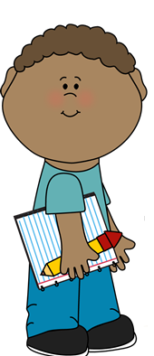

Linda and Mike **________** in my class. She **________** very cute but she **________** very tall. She **________** long plaited hair. She **________** some freckles too. Mike **________** short curly hair. He **________** fair skin. His skin **________** dark. He **________** tall.



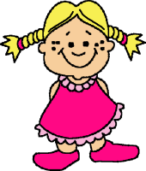





Tom and Cindy **________** my parents. My father **________** 40. His hair **________** long. It **________** short and straight. He **________** a very long nose. My mother **________** fair hair. It **________** medium length and wavy. Her mouth **________** big. Both my parents **________** small eyes.

This **________** Mr. Reynolds. He **________** my Math teacher. He teaches History. He **________** very friendly. He **________** a big moustache. His hair **________** short and brown. He **________** blue eyes. His eyes and nose **________** small, but quite big. His face **________** oval. He **________** a round face.

