3A Groupe 2
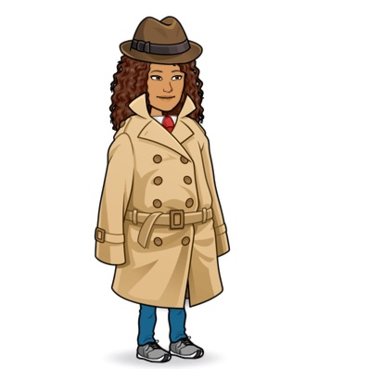
Travail pour la période du 11 au 15 octobre (quand le groupe 1 est en classe)
Hello again!
Let’s go back to our chapter on MYSTERIES…
Nous allons donc poursuivre notre chapitre sur les mystères.
Tu vas avoir plusieurs tâches à accomplir cette semaine :
- À l’aide du document ci-dessous, fais la correction du travail donné pendant le confinement (2è dossier)
- Lis le texte, puis complète le Crosswords sur Jack the Ripper. Apprends le wordbox.
- Lis le Toolbox 1 p 46 et fais les exercices 12,15 et 16 p 118
Have fun !
H

Lockdown activities
Correction
(2ème dossier)
I/ Queen Victoria
Queen Victoria was born in 1819. She came to the throne when she was only 18 years old. At the age of 21, she got married with Albert of Saxe-Coburg, a German Prince. Her husband died in 1861 at the young age of 42. She mourned his death for almost 10 years. For the rest of her reign she wore black. She died in 1901 at the age of 81. Queen Victoria had the longest reign in British history.
II/ Famous people in Victorian times
a)
Alexander Graham Bell invented the telephone.
Frederick Abberline investigated Jack the Ripper’s crimes.
Jack the Ripper murdered at least five women in London.
Lewis Carrol created Alice in Wonderland.
Robert Louis Stevenson created the characters of Doctor Jekyll and Mister Hyde.
Sir Arthur Conan Doyle wrote the famous adventures of Sherlock Holmes.
Thomas Edison made the first electric light bulb.
b)
The telephone was invented by Alexander Graham Bell
Jack the Ripper’s crimes were investigated by Frederick Abberline
At least five women were murdered by Jack the Ripper in London.
The characters of Doctor Jekyll and Mister Hyde were created by Robert Louis Stevenson.
The famous adventures of Sherlock Holmes were written by Sir Arhur Conan Doyle.
The first electric light bulb was made by Thomas Edison.
III/Victorian times
a) Une heure commune a été adoptée dans toutes les villes après la mise en place des chemins de fer et des trains.
b) Les maillots de bain couvraient le corps des femmes tout entier car elles n’avaient pas le droit de montrer leurs jambes ni même leurs chevilles.
c) Londres était très pollué parce que la plupart des foyers faisaient brûler du charbon plutôt que du bois.
d) Il y avait des employés dont le travail était d’aller frapper à la porte des ouvriers pour les réveiller.
IV/Jack the Ripper
He was a dangerous serial killer. He attacked several women in 1888. His name “Jack the Ripper” was created by the killer himself.
His method: Throats cuts => victimes égorgées; abdominal mutilations and removal of internal organs => mutilations au niveau du ventre et les organes étaient retirés.
V/ Wordsearch
The 15 words were: corpses, From Hell, killer, mutilation, suspect, crimes, investigation, letters, police, victims, kidney, London, prostitute, Whitechapel
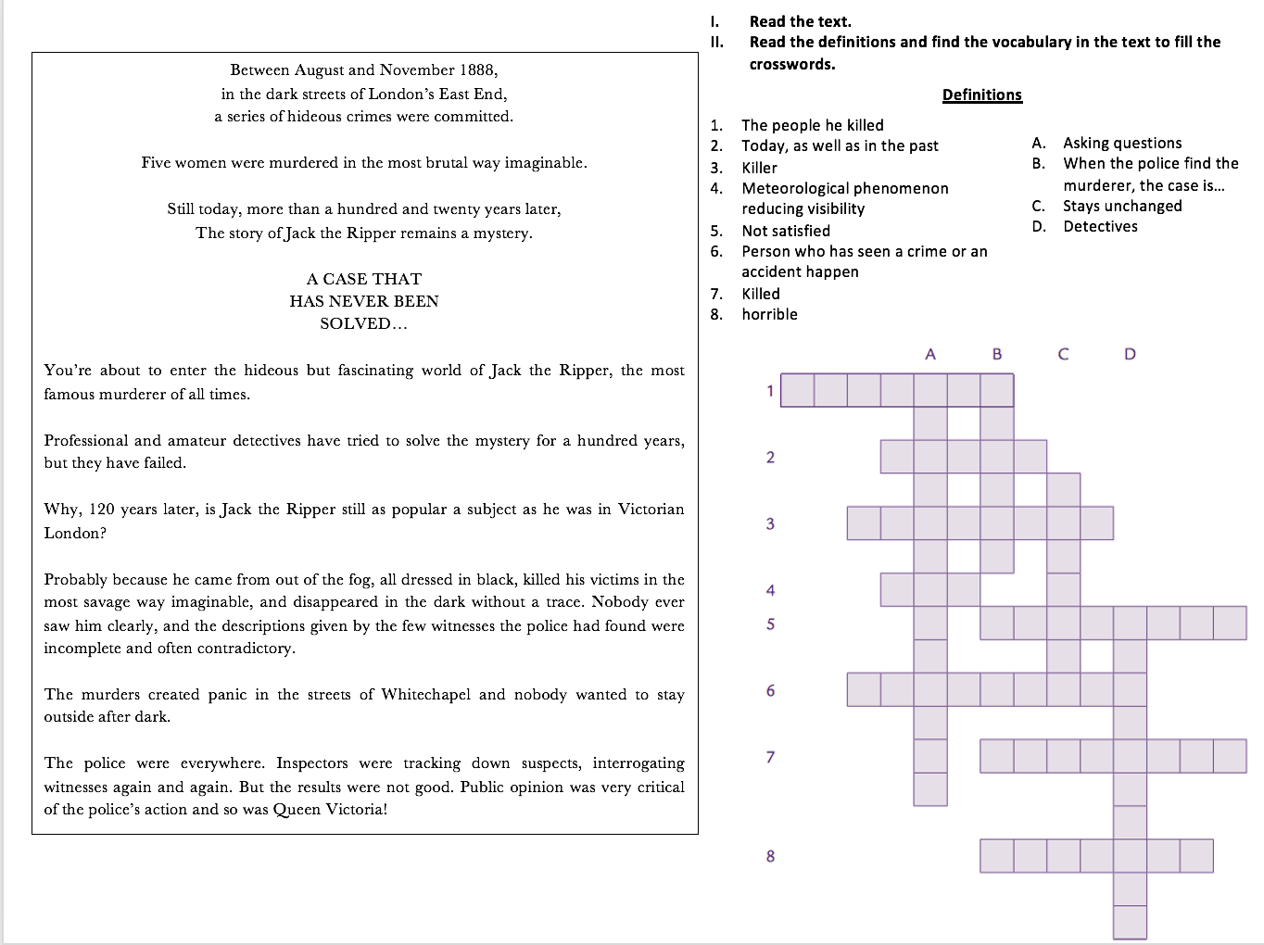
Wordbox : Crime investigation
a mystery a killer/a murderer a crime/a murder a victim a witness
investigation (= enquête, recherches) a detective / an inspector a suspect a clue (= un indice)
to kill/to murder/to commit a crime to investigate(= enquêter) to interrogate
to solve a mystery/a case

