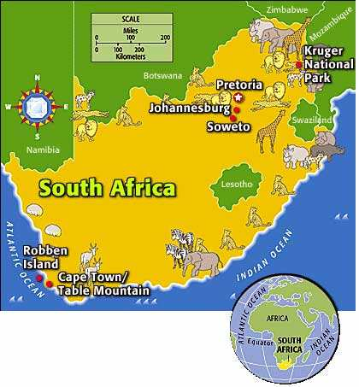
LEARN ABOUT SOUTH AFRICA
- A little bit of geography.
The Republic of South Africa is located in the ................. of the African continent. South Africa is bordered by the............................... Ocean and the ................................. Ocean.
One of the capital cities is named P............................ but it has also got a nickname (=surnom): “the city of Jacaranguas” because there are many beautiful trees in the city.

- The official languages
South Africa has 11 official languages.
E............................ is recognized as the language of commerce and science.
At home, most people (= la plupart des gens) speak Z............................... (23.8%), Xhosa (17.6%) and A............................... (13.3%).

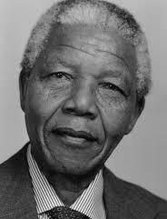
- South Africa and racism
Nelson M............................ was a great political leader. He fought against racism in South Africa.
In _ _ _ _ (date) he received the Nobel Peace Prize. In _ _ _ _ (date) he became the first black President of the Republic of South Africa. His nickname is ..........................; it was the name of a clan he was a member of.

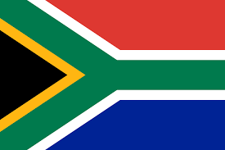
- The flag of the Republic of South Africa is b......................, y......................, g....................., w......................., r............. and b...................... (colours). The flag was created in _ _ _ _ (date). It is multi-coloured and is a symbol for the R............................ Nation.
The horizontal Y means ...........................................................
Black means .............................................................................
Yellow means ...........................................................................
Green means .............................................................................
White means .............................................................................
Red means ................................................................................
WORD BANK: Pretoria – Rainbow – 1994 – Zulu – Afrikaans – people of European origin - Atlantic - black people – unity – blood – the land – natural resources – Indian - gold – Madiba – English – the sky and oceans – south – Mandela – 1993
Blue means ...............................................................................

