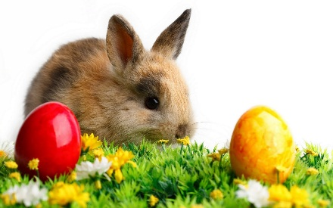
Easter

Easter is a Christian holiday honouring the death and new life of Jesus Christ. The symbols of Easter are eggs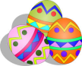, rabbits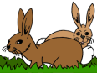, and spring flowers.
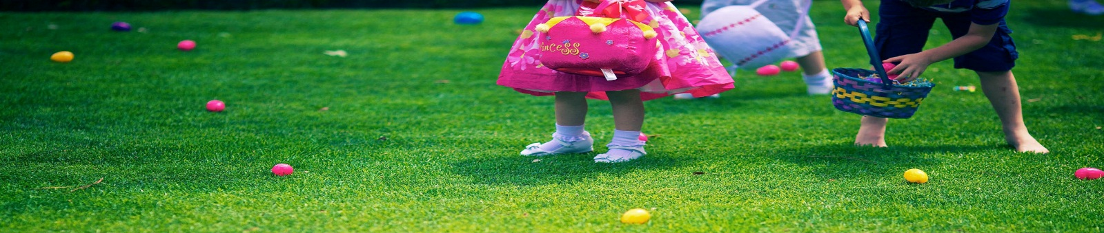
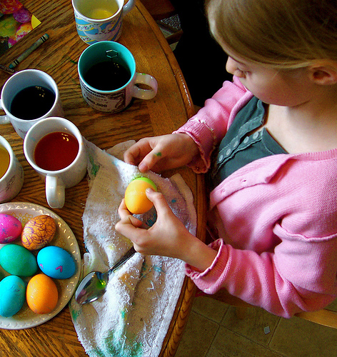
On Easter Sunday there are Easter egg hunts. Children look for hidden plastic eggs in the grass. They fill up their Easter baskets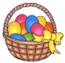 . They hope Easter Bunny 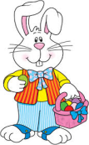has brought them many eggs, many chocolate bunnies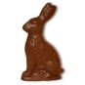, and many jelly beans.
A special Easter tradition is dyeing Easter eggs.
Many people eat a big Easter dinner with friends and family
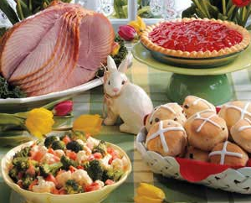
Dans le texte, trouve les équivalents en anglais et les réponses aux questions ci-dessous :
Pâques : …………………………………….
Le lapin de Pâques : …………………………………….
Une chasse aux œufs : …………………………………….
Un repas de Pâques : …………………………………….
Qu’est-ce que Pâques (l1) ? …………………………………………...
…………………………………………………………………………
Quels sont les symboles de Pâques ?.....................................................
…………………………………………………………………………
Qui apporte les œufs ? …………………………………….
Qu’apporte-t-il d’autre ? …………………………………….
Que fait-on pour Pâques (nomme au moins 3 activités) ?.....................
…………………………………………………………………………
…………………………………………………………………………

/

