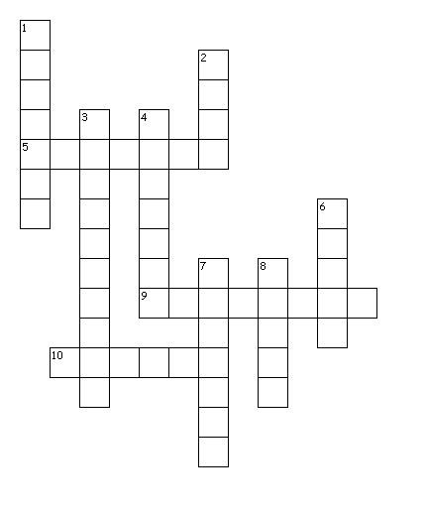

**Across**

5. The Republic of ...

9. 

10. … is the capital city of Ireland.

**Down**

1. Happy St ...’s Day

2. 7. 

3. 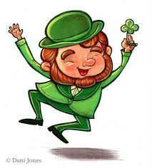 8. People wear … .

4. There are … in the streets.

6. St Patrick’s Day is on … 17th.



**Across**

5. The Republic of...

9. 

10. … is the capital city of Ireland.

**Down**

1. Happy St ...’s Day

2. 7. 

3.  8. People wear … .

4. There are … in the streets.

6. St Patrick’s Day is on … 17th.