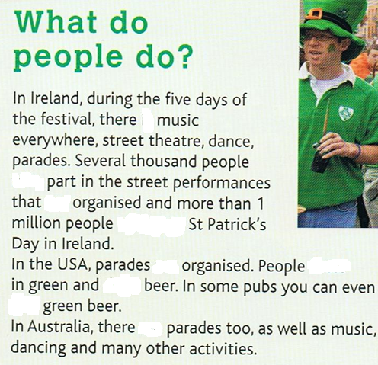

**Write the verbs in the sentences**.

are – are – are – drink – is – celebrate – take – dress - find



**Write the verbs in the sentences**.

are – are – are – drink – is – celebrate – take – dress - find



**Write the verbs in the sentences**.

are – are – are – drink – is – celebrate – take – dress - find



**Write the verbs in the sentences**.

are – are – are – drink – is – celebrate – take – dress - find



**Write the verbs in the sentences**.

are – are – are – drink – is – celebrate – take – dress - find



**Write the verbs in the sentences**.

are – are – are – drink – is – celebrate – take – dress - find



**Write the verbs in the sentences**.

are

are

are

drink

is

celebrate

take

dress

find