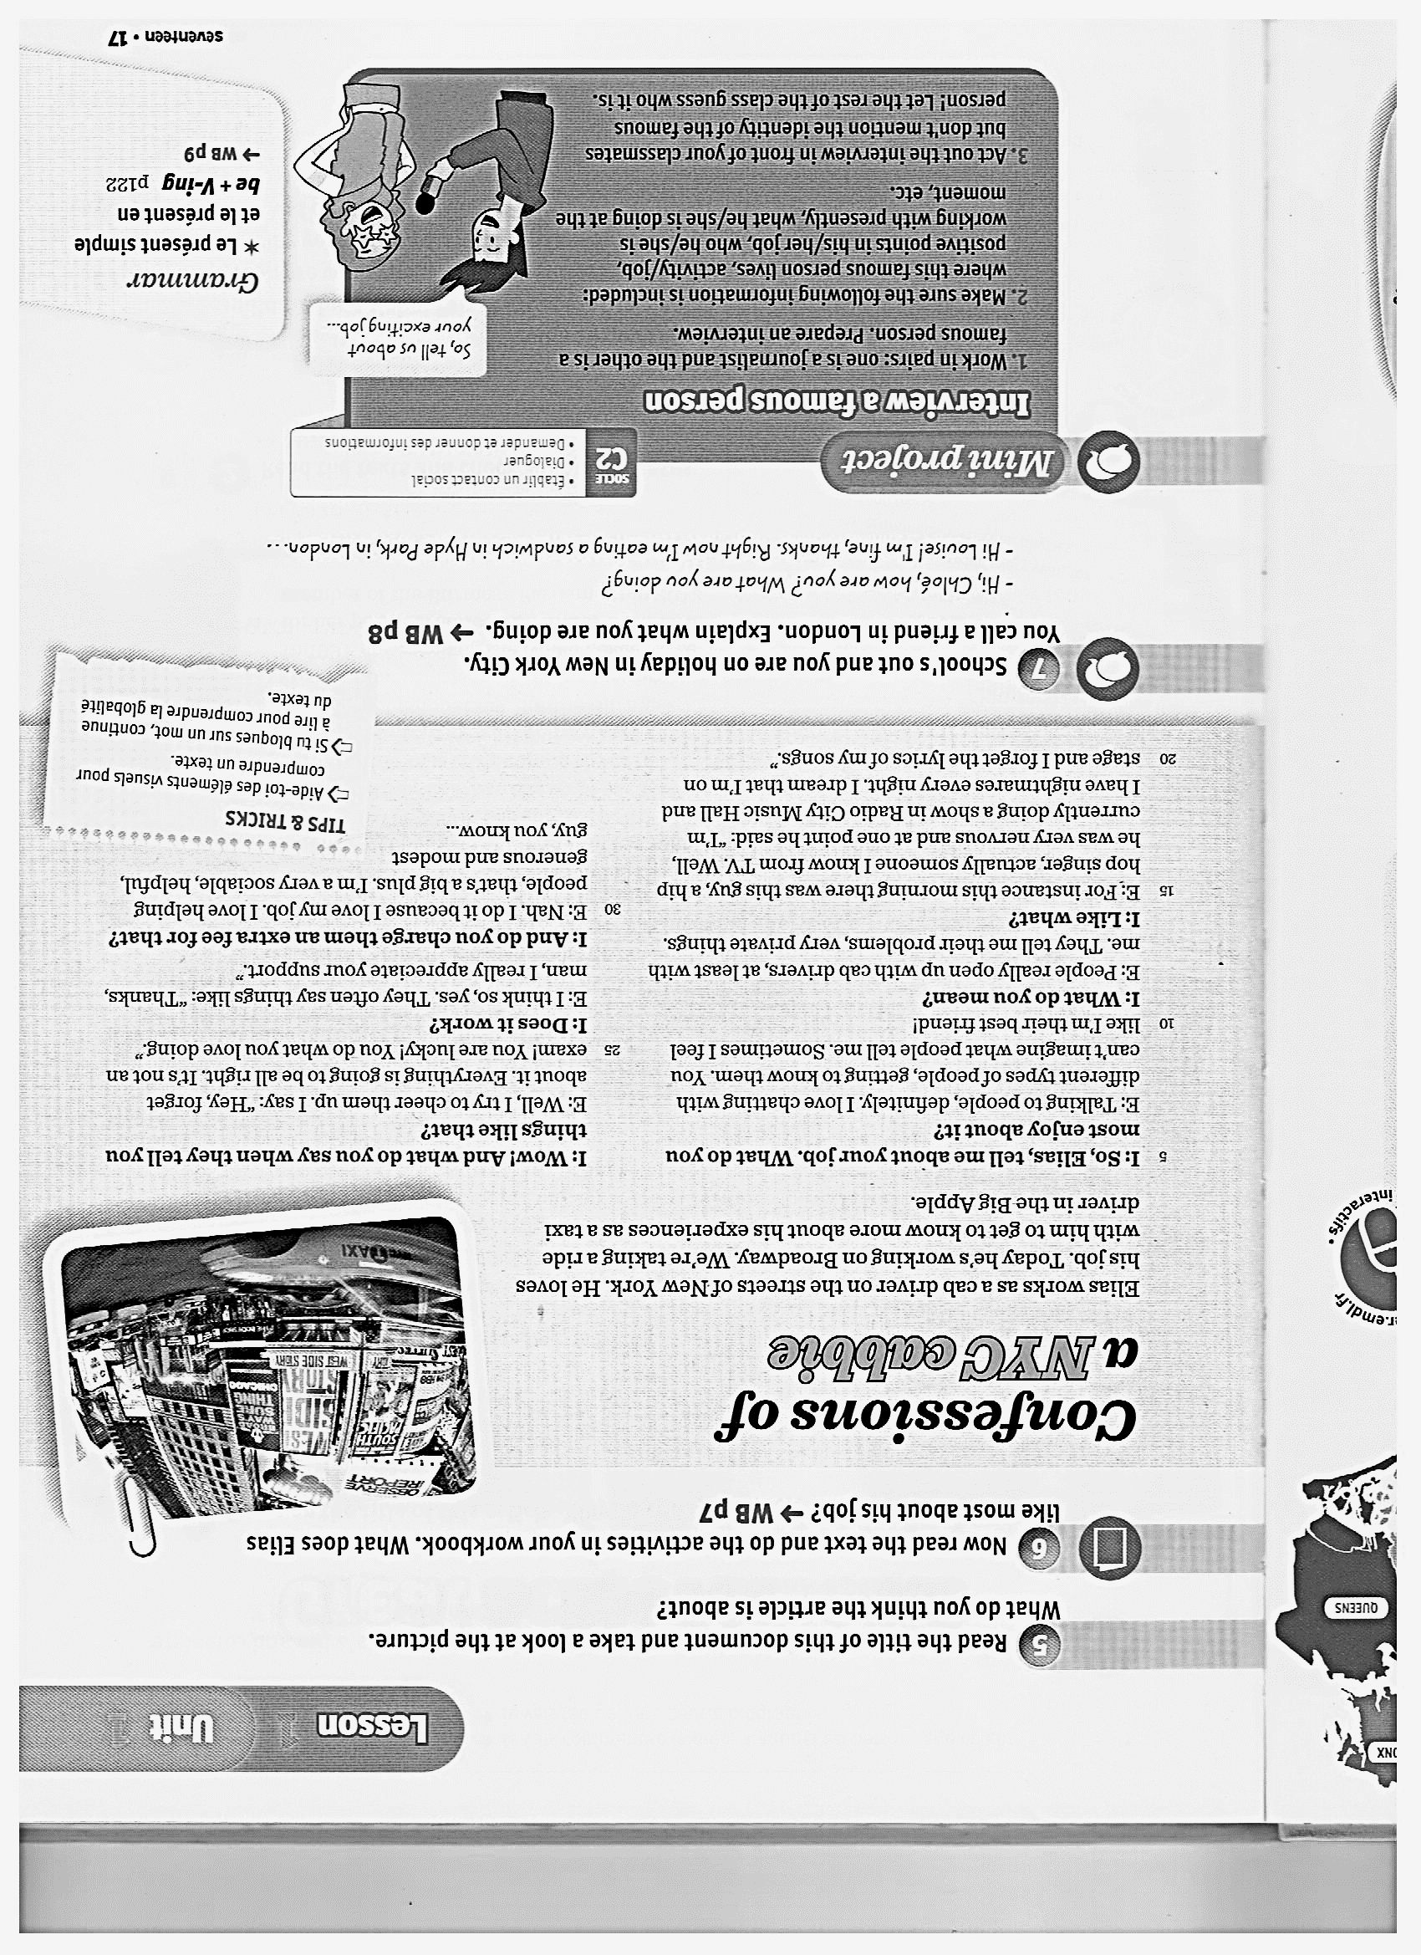





**The interview**

Where are they at that moment?

……………………………………………..…………………………………

What is Elias doing during the interview?

…………………………………………..

…………………………………………

What does Elias like most about his job?

………………………………………………………………………………………….

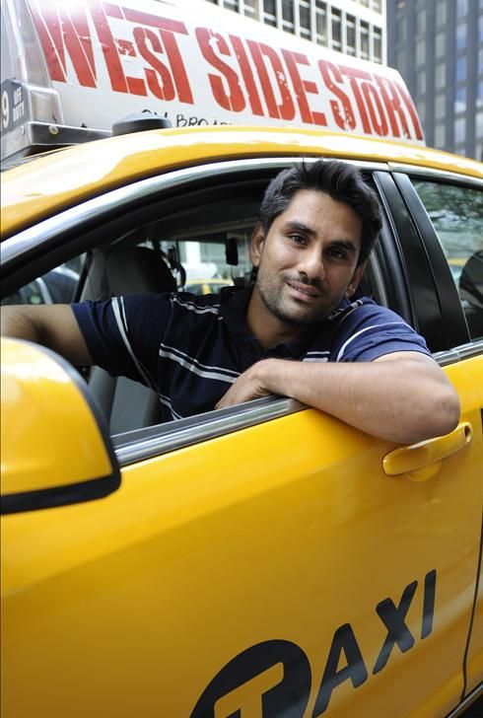

Name : ……………

Job : ………………

Address : …………..

Personality : ………..

……………………..

…………………………..

**Elias talks about a client who took a ride with him. Give information about him.**

………………………………………………………………………………………………………………………………………………………………………………………………………………………………………………………………………………………………..

**What did Elias do? Did he do it for free?** …………………………………………………..

………………………………………………………………………………………………