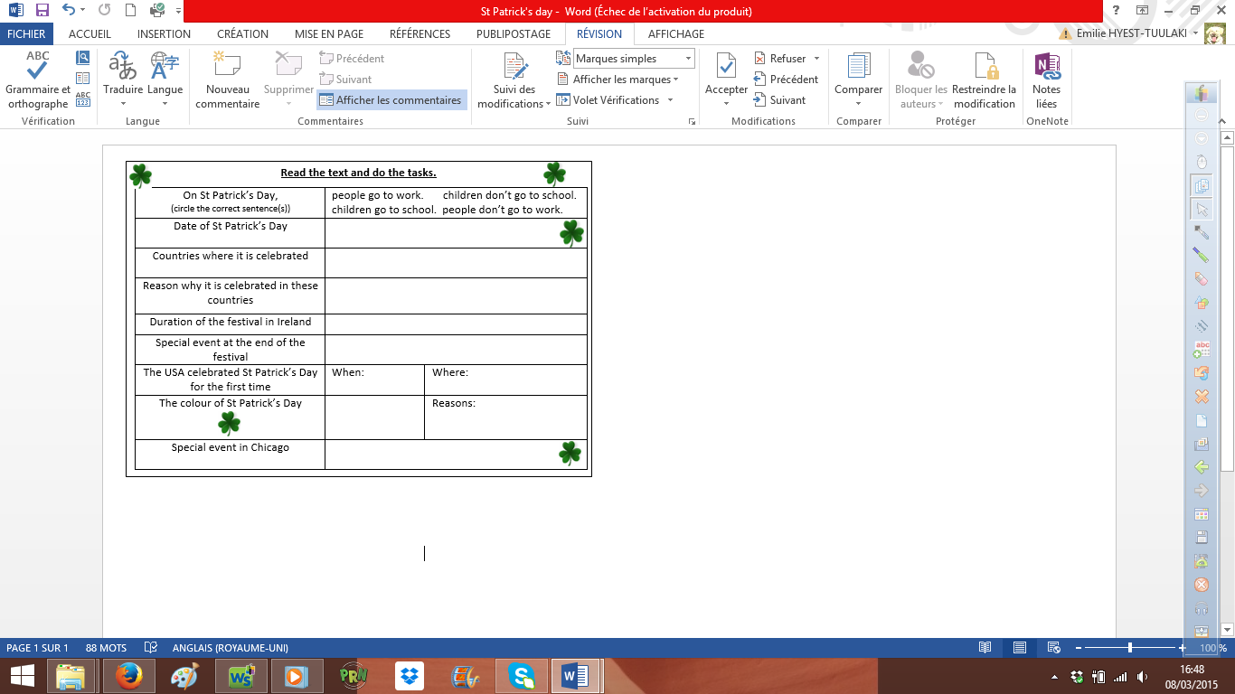

**Read the text and do the tasks.**

|  |  |  |
| --- | --- | --- |
| On St Patrick’s Day,  (circle the correct sentence(s)) | people go to work. children don’t go to school.  children go to school. people don’t go to work. | |
| Date of St Patrick’s Day |  | |
| Countries where it is celebrated |  | |
| Reason why it is celebrated in these countries |  | |
| Duration of the festival in Ireland |  | |
| Special event at the end of the festival |  | |
| The USA celebrated St Patrick’s Day for the first time | When: | Where: |
| The colour of St Patrick’s Day |  | Reasons: |
| Special event in Chicago |  | |







